## Първоначална настройка

CREATE DATABASE Minions;

USE Minions;

CREATE TABLE Countries

(

Id INT NOT NULL PRIMARY KEY IDENTITY,

Name VARCHAR(50) NOT NULL

);

CREATE TABLE Towns

(

Id INT NOT NULL PRIMARY KEY IDENTITY,

Name VARCHAR(50),

CountryCode INT,

FOREIGN KEY(CountryCode) REFERENCES Countries(Id)

);

CREATE TABLE Minions

(

Id INT NOT NULL PRIMARY KEY IDENTITY,

Name VARCHAR(50),

Age INT,

TownId INT,

FOREIGN KEY (TownId) REFERENCES Towns(Id)

);

CREATE TABLE EvilnessFactors

(

Id INT NOT NULL PRIMARY KEY IDENTITY,

Name VARCHAR(50)

);

CREATE TABLE Villains

(

Id INT NOT NULL PRIMARY KEY IDENTITY,

Name VARCHAR(50),

EvilnessFactorId INT,

FOREIGN KEY (EvilnessFactorId) REFERENCES EvilnessFactors(Id)

);

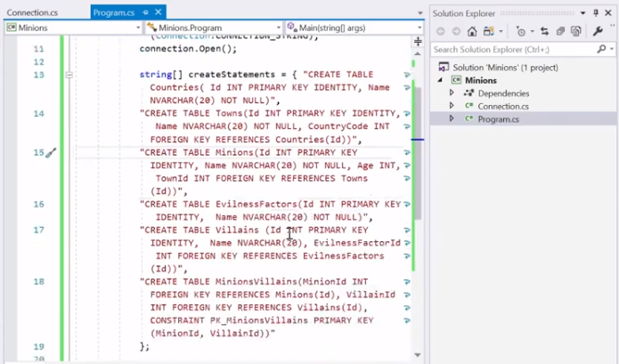CREATE TABLE MinionsVillains

(

MinionId INT,

VillainId INT,

FOREIGN KEY(MinionId) REFERENCES Minions(Id),

FOREIGN KEY(VillainId) REFERENCES Villains(Id)

);

INSERT INTO Countries (Name) VALUES

('Bulgaria'),

('Germany'),

('Polland'),

('Greece'),

('Russia');

INSERT INTO Towns(Name, CountryCode) VALUES

('Sofia', 1),

('Berlin', 2),

('Varshava', 3),

('Atina', 4),

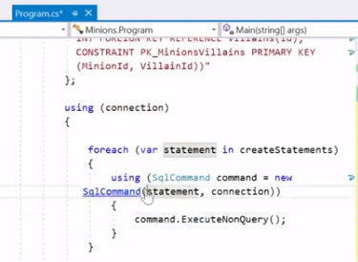('Moskva', 5);

INSERT INTO Minions (Name, Age, TownId) VALUES

('AAA', 11, 1),

('BBB', 22, 2),

('CCC', 33, 3),

('DDD', 44, 4),

('EEE', 55, 5);

INSERT INTO EvilnessFactors (Name) VALUES

('Super Good'),

('Good'),

('Evil'),

('Super Evil');

INSERT INTO Villains (Name, EvilnessFactorId) VALUES

('PPP', 1),

('QQQ', 2),

('RRR', 3),

('SSS', 4),

('TTT', 4);

INSERT INTO MinionsVillains(MinionId, VillainId) VALUES

(1,1),

(2,2),

(3,3),

(4,4),

(5,5);

## Имена на злодеи

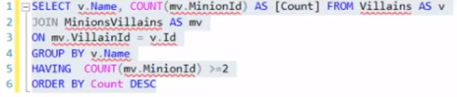using System;

using System.Data.SqlClient;

namespace Problem2

{

class Program

{

static void Main(string[] args)

{

string connectionString = "Server=KPETROVA\\SQLEXPRESS01; Database=Minions; Integrated Security=true";

SqlConnection connection = new SqlConnection(connectionString);

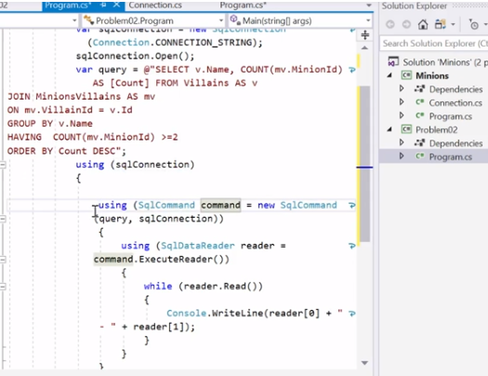 connection.Open();

var sql = "SELECT Name, Count(MinionId)" +

"FROM Villains " +

"JOIN MinionsVillains " +

"on Id = VillainId " +

"group by Name";

SqlCommand command = new SqlCommand(sql, connection);

SqlDataReader reader = command.ExecuteReader();

while (reader.Read())

{

Console.WriteLine("{0}: {1}", reader[0], reader[1]);

}

reader.Close();

connection.Close();

}

}

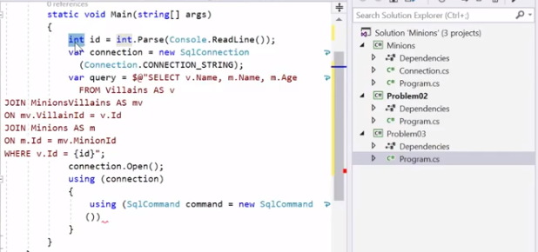}

## Имена на миниони

using System;

using System.Data.SqlClient;

namespace Problem3

{

class Program

{

static void Main(string[] args)

{

string connectionString = "Server=KPETROVA\\SQLEXPRESS01; Database=Minions; Integrated Security=true";

SqlConnection connection = new SqlConnection(connectionString);

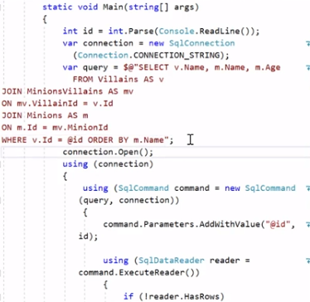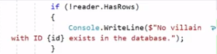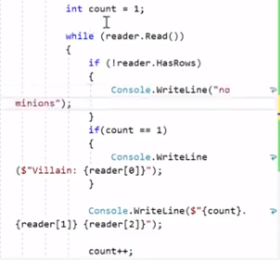

connection.Open();

int Id = int.Parse(Console.ReadLine());

string sql = $"SELECT Name FROM Villains WHERE Id = {Id}";

SqlCommand command = new SqlCommand(sql, connection);

var result = command.ExecuteScalar();

if (result == null)

{

Console.WriteLine($"No villain with ID {Id} exists in the database.");

}

else

{

string villainName = result.ToString();

Console.WriteLine($"Villain: {villainName}");

string findMinionsSQL = "SELECT m.Name, m.Age " +

"From Minions AS m " +

"JOIN minionsvillains AS mv " +

"ON mv.MinionId = m.Id " +

$"WHERE mv.villainId = {Id} " +

"ORDER BY m.Name";

command = new SqlCommand(findMinionsSQL, connection);

SqlDataReader reader = command.ExecuteReader();

if (!reader.HasRows)

{

Console.WriteLine("No minions");

}

else

{

int count = 0;

while (reader.Read())

{

count++;

Console.WriteLine($"{count} {reader[0]} {reader[1]}");

}

}

reader.Close();

}

connection.Close();

}

}

}

## Добавете минион

using System;

using System.Data.SqlClient;

using System.Linq;

namespace Problem4

{

class Program

{

static void Main(string[] args)

{

string connectionString = "Server=KPETROVA\\SQLEXPRESS01; Database=Minions; Integrated Security=true";

SqlConnection connection = new SqlConnection(connectionString);

connection.Open();

string message = "";

string[] minionData = Console.ReadLine().Split().ToArray();

string[] villainData = Console.ReadLine().Split().ToArray();

string town = minionData[3];

string sql = $"SELECT COUNT(*) FROM Towns WHERE Name = '{town}';";

SqlCommand command = new SqlCommand(sql, connection);

int result = int.Parse(command.ExecuteScalar().ToString());

if (result == 0)

{

sql = $"INSERT INTO Towns (Name, CountryCode) VALUES ('{town}', 2);"; //countrycode ???

command = new SqlCommand(sql, connection);

command.ExecuteNonQuery();

message += $"Town {town} added to the database.\n";

}

string villain = villainData[1];

sql = $"SELECT COUNT(*) FROM Villains WHERE Name = '{villain}'";

command = new SqlCommand(sql, connection);

result = int.Parse(command.ExecuteScalar().ToString());

if (result == 0)

{

sql = $"INSERT INTO Villains (Name, EvilnessFactorId) VALUES ('{villain}', 3);";

command = new SqlCommand(sql, connection);

command.ExecuteNonQuery();

message += $"Villain {villainData[1]} added to the database.\n";

}

sql = $"SELECT Id FROM Towns WHERE Name = '{town}';";

command = new SqlCommand(sql, connection);

int townId = int.Parse(command.ExecuteScalar().ToString());

sql = $"Select Id FROM Villains WHERE Name = '{villain}';";

command = new SqlCommand(sql, connection);

int villainId = int.Parse(command.ExecuteScalar().ToString());

sql = "INSERT INTO Minions (Name, Age, TownId) " +

$"VALUES ('{minionData[1]}', '{minionData[2]}', {townId})";

command = new SqlCommand(sql, connection);

command.ExecuteNonQuery();

string minionName = minionData[1];

sql = $"SELECT Id FROM Minions WHERE Name = '{minionName}';";

command = new SqlCommand(sql, connection);

int minionId = int.Parse(command.ExecuteScalar().ToString());

sql = $"INSERT INTO MinionsVillains (MinionId, VillainId) VALUES ({minionId}, {villainId});";

command = new SqlCommand(sql, connection);

command.ExecuteNonQuery();

message += $"Successfully added {minionName} to be minion of {villain}\n";

Console.WriteLine(message.ToString());

connection.Close();

}

}

}

## Промяна на регистъра на имената на градовете

using System;

using System.Collections.Generic;

using System.Data.SqlClient;

namespace Problem5

{

class Program

{

static void Main(string[] args)

{

string connectionString = "Server=KPETROVA\\SQLEXPRESS01; Database=Minions; Integrated Security=true";

SqlConnection connection = new SqlConnection(connectionString);

connection.Open();

string countryName = Console.ReadLine();

using (connection)

{

string sql = $"SELECT Id FROM Countries WHERE Name = '{countryName}'";

SqlCommand command = new SqlCommand(sql, connection);

var countryId = command.ExecuteScalar();

if (countryId == null)

{

Console.WriteLine("No country.");

}

else

{

sql = $"SELECT COUNT(*) FROM Towns WHERE CountryCode = {countryId}";

command = new SqlCommand(sql, connection);

int townsCount = int.Parse(command.ExecuteScalar().ToString());

sql = $"SELECT * FROM Towns WHERE CountryCode = {countryId}";

command = new SqlCommand(sql, connection);

SqlDataReader reader = command.ExecuteReader();

var townNamesAffected = new List<string>();

var townIdsAffected = new List<int>();

using (reader)

{

if (!reader.HasRows)

{

Console.WriteLine("No town names were affected.");

reader.Close();

connection.Close();

return;

}

while (reader.Read())

{

string townName = (string)reader["Name"];

int townId = (int)reader["Id"];

townNamesAffected.Add(townName.ToUpper());

townIdsAffected.Add(townId);

}

}

for (int i = 0; i < townIdsAffected.Count; i++)

{

sql = $"UPDATE Towns SET Name = '{townNamesAffected[i].ToUpper()}' " +

$"WHERE Id = {townIdsAffected[i]}";

new SqlCommand(sql, connection).ExecuteNonQuery();

}

Console.WriteLine($"{townsCount} town names were affected.");

Console.WriteLine($"[{string.Join(", ", townNamesAffected)}]");

}

}

}

}

}

## *Премахване на злодей

using System;

using System.Data.SqlClient;

namespace Problem6

{

class Program

{

static void Main(string[] args)

{

string connectionString = "Server=KPETROVA\\SQLEXPRESS01; Database=Minions; Integrated Security=true";

SqlConnection connection = new SqlConnection(connectionString);

connection.Open();

int villainId = int.Parse(Console.ReadLine());

using (connection)

{

SqlCommand command = new SqlCommand("SELECT Id FROM Villains WHERE Id = @Id", connection);

command.Parameters.AddWithValue("@Id", villainId);

var result = command.ExecuteScalar();

if (result == null)

{

Console.WriteLine("No such villain was found.");

connection.Close();

return;

}

command = new SqlCommand("SELECT COUNT(*) FROM MinionsVillains WHERE VillainId = @Id", connection);

command.Parameters.AddWithValue("@Id", villainId);

int minionsCount = int.Parse(command.ExecuteScalar().ToString());

command = new SqlCommand("DELETE FROM MinionsVillains WHERE VillainId = @Id", connection);

command.Parameters.AddWithValue("@Id", villainId);

command.ExecuteNonQuery();

command = new SqlCommand("SELECT Name FROM Villains WHERE Id = @Id", connection);

command.Parameters.AddWithValue("@Id", villainId);

string villainName = command.ExecuteScalar().ToString();

command = new SqlCommand("DELETE FROM Villains WHERE Id = @Id", connection);

command.Parameters.AddWithValue("@Id", villainId);

command.ExecuteNonQuery();

Console.WriteLine($"{villainName} was deleted.");

Console.WriteLine($"{minionsCount} minions were released.");

}

}

}

}

## Изведете всички имена на миниони

using System;

using System.Collections.Generic;

using System.Data.SqlClient;

namespace Problem7

{

class Program

{

static void Main(string[] args)

{

var minions = new List<string>();

SqlConnection connection = new SqlConnection("Server=KPETROVA\\SQLEXPRESS01; Database=Minions; Integrated Security=true");

connection.Open();

using (connection)

{

string sql = "SELECT Name FROM Minions";

var command = new SqlCommand(sql, connection);

var reader = command.ExecuteReader();

while (reader.Read())

{

string name = reader["Name"].ToString();

minions.Add(name);

}

reader.Close();

int count = minions.Count;

for (int i = 0; i < count / 2; i++)

{

Console.WriteLine(minions[i]);

Console.WriteLine(minions[count - 1 - i]);

}

if (count % 2 == 1)

{

Console.WriteLine(minions[count / 2]);

}

}

}

}

}

## Увеличение на възраст на минион

using System;

using System.Collections.Generic;

using System.Data.SqlClient;

using System.Linq;

using System.Text;

using System.Threading.Tasks;

namespace Problem8

{

class Program

{

static void Main(string[] args)

{

int[] ids = Console.ReadLine().Split().Select(int.Parse).ToArray();

SqlConnection connection = new SqlConnection("Server=KPETROVA\\SQLEXPRESS01; Database=Minions; Integrated Security=true");

connection.Open();

using (connection)

{

for (int i = 0; i < ids.Length; i++)

{

string sql = $"SELECT * FROM Minions WHERE Id = @id";

var command = new SqlCommand(sql, connection);

command.Parameters.AddWithValue("@id", ids[i]);

var reader = command.ExecuteReader();

reader.Read();

string name = reader["Name"].ToString();

reader.Close();

string convertedName = name[0].ToString().ToUpper() + name.Substring(1);

var updateCmd = $"UPDATE Minions SET Name = '{convertedName}', Age = Age+1 WHERE Id = {ids[i]}";

var updateCommand = new SqlCommand(updateCmd, connection);

updateCommand.ExecuteNonQuery();

}

string sqlShow = "SELECT Name, Age FROM Minions";

var commandShow = new SqlCommand(sqlShow, connection);

var printer = commandShow.ExecuteReader();

while (printer.Read())

{

string minionName = (string)printer["Name"];

int age = (int)printer["Age"]; //int.Parse(printer["Age"].ToString());

Console.WriteLine($"{minionName} {age}");

}

}

}

}

}